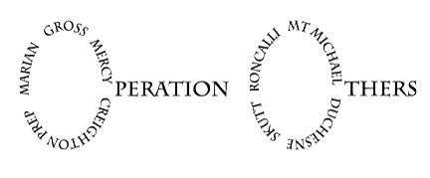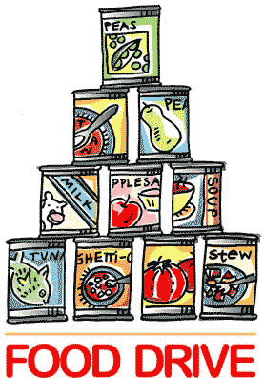

Thank you for helping Omaha families without enough.

Students that bring 3 or more cans of fruit will receive a free donut.

## Operation Others Canned Fruit Drive is October 10-15.

### Collected food will be delivered to Omaha families with many other food items this Christmas by Operation Others

## Bring canned fruit (no glass containers) to the Loyola Room from 7:15am-8am each morning the week of October 10-15.

## Donate cans of fruit to be included in food boxes for Omaha families in need!